Hello,

I bought the explosive kittens party pack about 6 months ago. Now I would like to buy zombie kittens, but probably these two expansions have different backs. Browsing the internet looking for a zombie kitten with the same back I found a guy on reddit with the same problem, he told me to write to you.

Attached is the photo of the back I'm referring to.

Best regards.

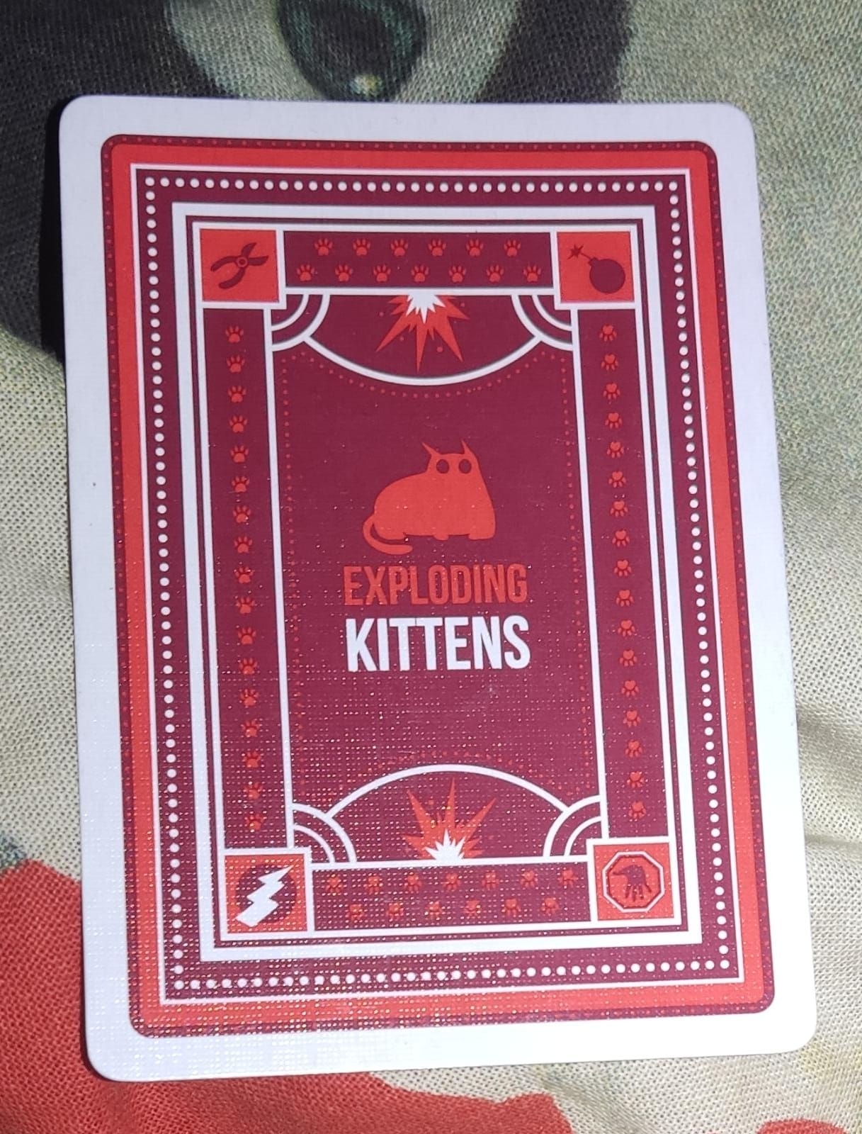

Hi, Emanuele!  
  
Nothing ruffles our whiskers more than mismatched Kittens! In order to ensure that we send you the correct version, could you please send us a few things?  
  
- A picture of the box - front and back - for your core deck (e.g. Party Pack, translated OE, etc.)  
- Your mailing address in the following format:  
  
Full name:  
Address line 1:  
Address line 2:  
Address city:  
Address state:  
Address postal code:  
Address country:  
Address phone number:  
  
Lastly, could you please let us know where you originally purchased your core deck?  
   
Looking forward to hearing back and getting things taken care of ASAP! :)  
  
Hugs & whiskers,  
Brooke

Exploding Kittens

Full name: Emanuele Costanzo

Address line 1: Via Giovanni Meli n.6

Address line 2:

Address city: Trecastagni

Address state: Catania

Address postal code: 95039

Address country: Italy

Address phone number: +39 3311496143

I bought it on amazon

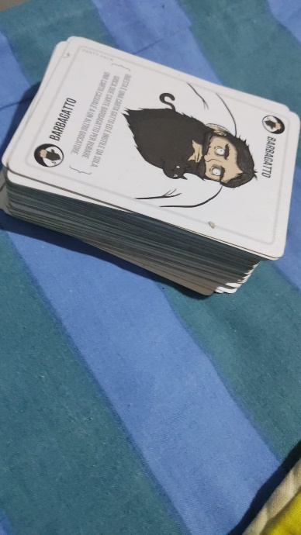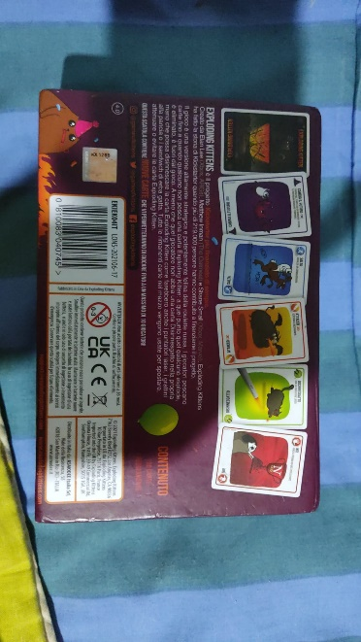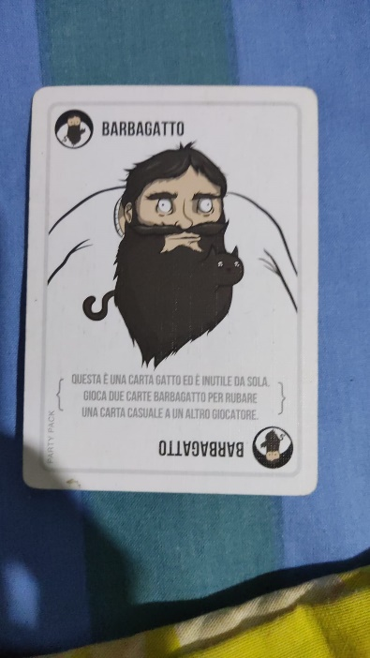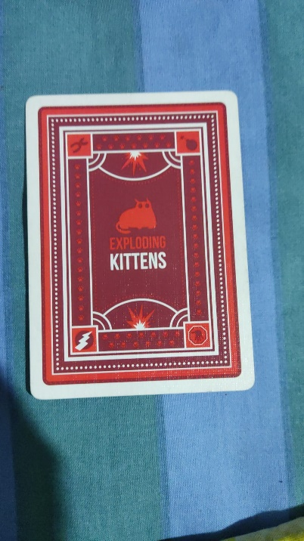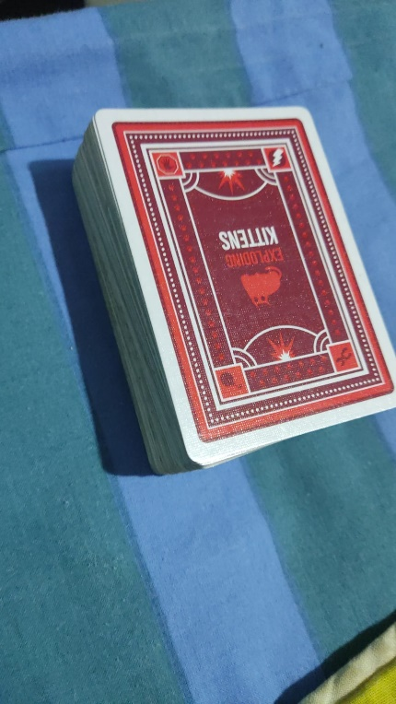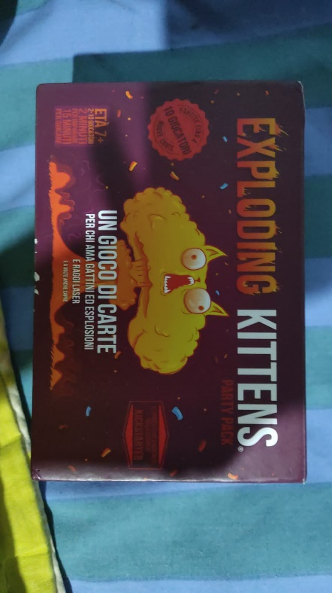

Hi there,   
   
I have placed a brand-new order for you. Your miss match kittens will be resolved soon!   
   
As soon as your order is on the way you'll receive tracking information. Please feel furry to reach out with any questions or concerns.   
   
Meow,   
Brooke

Exploding Kittens

Hey,

I ordered a exploding kitten party pack some days ago, I tracked my order and i saw that the pack is been stucked in Holland for a week. Is it normal?

How long does it usually take to ship to Italy?

My order is #EK-219147 and the DHL Express tracking number is JVGL06218275001007847652.

Thank you very much

I really love your game

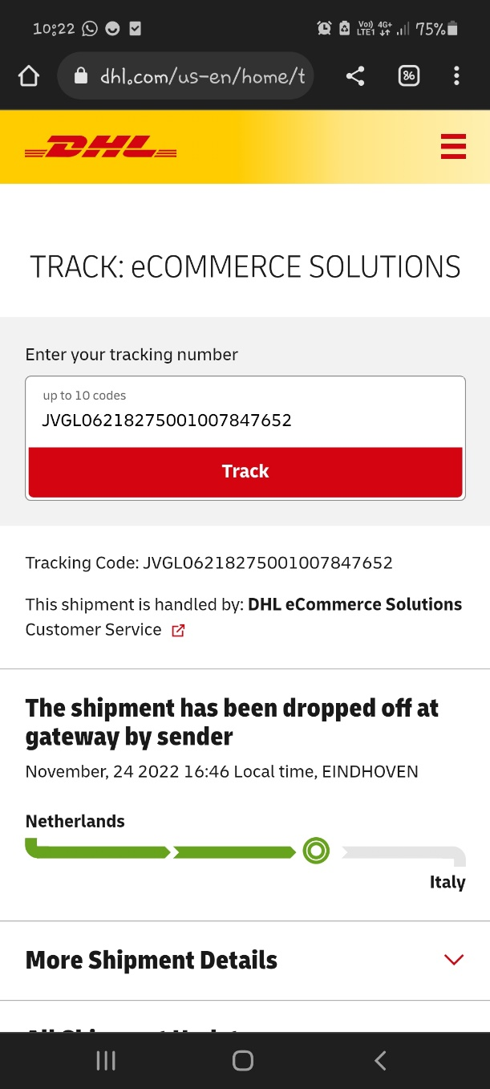

Hi Emanuele,  
  
Thanks for reaching out.  
  
Sorry to hear your order still hasn't arrived! Given the delay, we'll assume it was lost in transit and ship you a replacement. You should receive an additional email with tracking information once it's headed your way, again. Please let me know if you need anything else!  
  
Meow,  
Brooke

Exploding Kittens